建立Spring Boot Data JPA專案
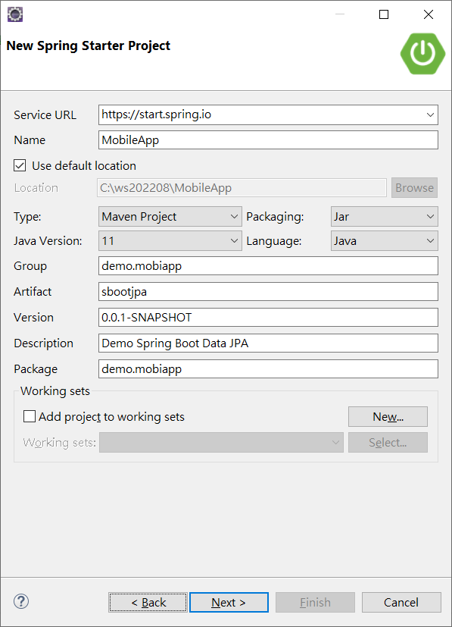
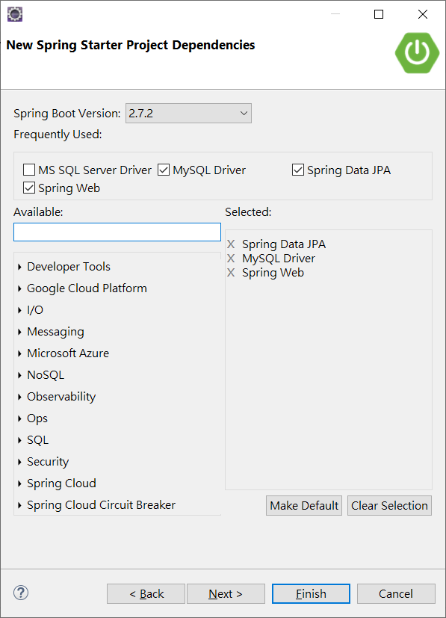
我們要建立以下mysql 資料庫及關連表
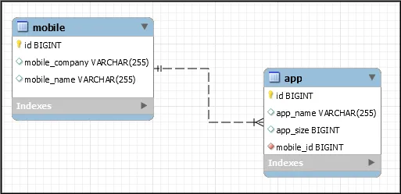
createDatabaseIfNotExist=true 這個屬性可以由系統自動產生資料庫
application.properties

server.servlet.context-path=/mobile
server.port=8080
spring.jpa.hibernate.ddl-auto=update
spring.datasource.url=jdbc:mysql://localhost:3306/mydb?createDatabaseIfNotExist=true&useSSL=false
spring.datasource.username=root
spring.datasource.password=1234
spring.datasource.driver-class-name =com.mysql.cj.jdbc.Driver
spring.jpa.show-sql= true
## Hibernate Properties
# The SQL dialect makes Hibernate generate better SQL for the chosen database
spring.jpa.properties.hibernate.dialect = org.hibernate.dialect.MySQL8InnoDBDialect
#To format SQL queries generated by Hibernate
spring.jpa.properties.hibernate.format_sql=true
#change port number
#server.port=8080

建立Mobile Apps 兩個Entity Class

import java.util.Set;
import javax.persistence.CascadeType;
import javax.persistence.Column;
import javax.persistence.Entity;
import javax.persistence.GeneratedValue;
import javax.persistence.GenerationType;
import javax.persistence.Id;
import javax.persistence.OneToMany;
import javax.persistence.Table;

@Entity
@Table(name = "mobile")
public class Mobile {
@Id
@GeneratedValue(strategy = GenerationType.IDENTITY)
private long id;

@Column(name = "mobile_name", length = 255)
private String mobileName;

@Column(name = "mobile_company", length = 255)
private String mobileCompany;

@OneToMany(mappedBy = "mobile", cascade = CascadeType.ALL ,fetch = FetchType.EAGER )
private Set<Apps> apps;

public Mobile() {
}
@Override
public String toString() {
return "Mobile [id=" + id + ", mobileName=" + mobileName + ", mobileCompany=" + mobileCompany + ", apps=" + apps
+ "]";
}

public long getId() {
return id;
}
public void setId(long id) {
this.id = id;
}
public String getMobileName() {
return mobileName;
}
public void setMobileName(String mobileName) {
this.mobileName = mobileName;
}
public String getMobileCompany() {
return mobileCompany;
}
public void setMobileCompany(String mobileCompany) {
this.mobileCompany = mobileCompany;
}
public Set<Apps> getApps() {
return apps;
}
public void setApps(Set<Apps> apps) {
this.apps = apps;
}

}

import javax.persistence.Column;
import javax.persistence.Entity;
import javax.persistence.GeneratedValue;
import javax.persistence.GenerationType;
import javax.persistence.Id;
import javax.persistence.JoinColumn;
import javax.persistence.ManyToOne;
import javax.persistence.Table;

@Entity
@Table(name = "app")
public class Apps {
@Id
@GeneratedValue(strategy = GenerationType.IDENTITY)
private long id;

@Column(name = "app_name", length = 255)
private String appName;

@Column(name = "app_size", length = 255)
private long appSize;

// JoinColumn會在多的表格建立一個mobile_id跟主表格的關聯欄位
@ManyToOne
@JoinColumn(name = "mobile_id", nullable = false , referencedColumn=”id”)
private Mobile mobile;

public Apps() {}

public Apps(String appName, long appSize, Mobile mobile) {

this.appName = appName;
this.appSize = appSize;
this.mobile = mobile;
}

@Override
public String toString() {
return "Apps [id=" + id + ", appName=" + appName + ", appSize=" + appSize + "]";
}

public long getId() {
return id;
}

public void setId(long id) {
this.id = id;
}

public String getAppName() {
return appName;
}

public void setAppName(String appName) {
this.appName = appName;
}

public long getAppSize() {
return appSize;
}

public void setAppSize(long appSize) {
this.appSize = appSize;
}

public Mobile getMobile() {
return mobile;
}

public void setMobile(Mobile mobile) {
this.mobile = mobile;
}

}
建立資料表自動生成的repository 程式
package demo.mobiapp.repository;

import java.util.List;
import org.springframework.data.jpa.repository.JpaRepository;
import org.springframework.stereotype.Repository;
import demo.mobiapp.model.Apps;

@Repository
public interface AppRepository extends JpaRepository<Apps, Long> {
List<Apps> findByMobileId(long id);
// List<Apps> findByMobileName(Mobile mobile);
}

package demo.mobiapp.repository;

import java.util.List;
import org.springframework.data.jpa.repository.JpaRepository;
import org.springframework.stereotype.Repository;
import demo.mobiapp.model.Mobile;

@Repository
public interface MobileRepository extends JpaRepository<Mobile, Long> {
List<Mobile> findByMobileName(String mName);
}
最後是測試程式
package demo.mobiapp;

import org.springframework.boot.SpringApplication;
import org.springframework.boot.autoconfigure.SpringBootApplication;
import org.springframework.context.ApplicationContext;

import demo.mobiapp.model.*;
import demo.mobiapp.repository.*;
import java.util.*;
@SpringBootApplication
public class MobileAppApplication {

public static void main(String[] args) {
ApplicationContext context =SpringApplication.run(MobileAppApplication.class, args);
MobileRepository mobileRepository = context.getBean(MobileRepository.class);
AppRepository appRepository = context.getBean(AppRepository.class);

//1. Save into db
// Mobile mobile = new Mobile("Galaxy","Samsung");
// mobileRepository.save(mobile);
// appRepository.save(new Apps("Whatsapp",25,mobile));
// appRepository.save(new Apps("Be My Eyes",18,mobile));
// appRepository.save(new Apps("Battleground",250,mobile));
//2. Find All.
List<Mobile> mobiles = mobileRepository.findAll();
for(Mobile m: mobiles) {
System.out.println(m);
}

//3. Find By Mobile Name
List<Mobile> name = mobileRepository.findByMobileName("Galaxy");
for(Mobile m: name) {
System.out.println(m);
}

//4. Getting parent table from child
List<Apps> list= appRepository.findByMobileId(1);
System.out.println(list.get(0).getMobile());

}

}

